|  |  |  |
| --- | --- | --- |
| Inside Cissbury, Issue 30, July 2024 by insidecommunity - Issuu | **HOLLY CLASS** | Europe Clipart - colorful-saint-basil-cathedral-moscow ... |

Dear Parents and Carers,

Welcome back to the Summer Term - I hope you have had a lovely Easter break. Here are some highlights for this term (more details can be found within the topic overview):

* In art, children will use the *‘Lion Man’* from the book*, 'Vincent's Starry Night and Other Stories'* as a stimulus for their drawing, sculpture, and painting.
* Children will continue learning to play the recorder, adding the notes low E and D, F and C sharp in a new unit called ‘Earthlight’.
* Children will cook with Mrs van Zanten as part of the design and technology unit.

This term, Holly Class will be approaching their history unit through enquiry-based learning, which encourages children to take ownership of their learning by engaging them in a process of enquiry. It is a child-centred, constructivist approach where children actively explore topics by asking questions, researching, and interpreting information, fostering critical thinking and problem-solving skills.

**Summer Trip**

You will have recently received a letter about our visit to Cissbury Ring on Tuesday 6th May. During the visit, a local guide will lead the children on a fascinating journey through the historical significance of Cissbury Ring, exploring its role across different periods in history.

**START OF THE DAY**

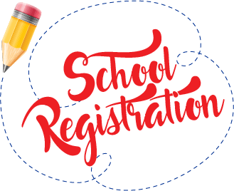The gates open at 8:40am with registration at 8:50am. Your child will have the opportunity to do some spelling activities / quiet reading during this time and they will also be able to access Accelerated Reader quizzes. **Arriving on time is a great start to the day, putting your child in the right frame of mind to make the most of the day's learning. Good punctuality is linked to good attendance which leads to better outcomes for children.** **Current attendance up to the end of the Spring term is 97%.**

**P.E. AND GAMES**

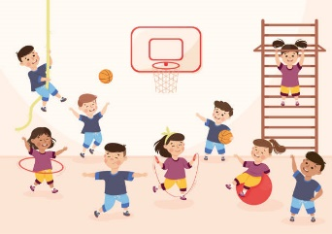We have adopted a new PE scheme which we will be starting this term. Any child who does not have their full PE kit, including suitable trainers for outside, will be unable to take part. **Please ensure that all of your child’s kit is named**. **Earrings should be removed for PE and Games.** If this is not possible, then they should be covered with micro-pore tape provided by you. Long hair must be tied back. Holly Class will have outside PE on a Friday and we will be inside every Monday.

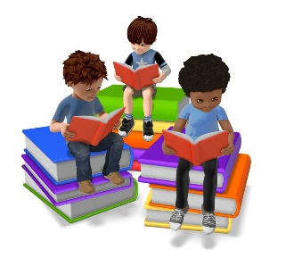**READING**

As a school, we work hard to ensure that all our children receive positive reading experiences, whether it be through quality texts in English or different awards to promote reading for pleasure. Unfortunately, there are still children in Holly Class who are not reading regularly. Please ensure your child is reading daily and updating their reading journal, which is part of their weekly homework. Children are given opportunities every morning to complete an Accelerated Reader quiz linked to their completed book. Thank you for your continued support with reading. If your child is struggling to find appropriate reading material, please let me know and I will help them to choose their next book.

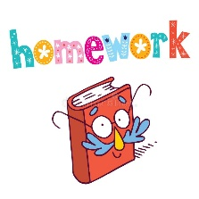**HOMEWORK**

Children will be issued with a new homework grid for this term. It was extremely pleasing to see the high-quality work produced during the Spring term, some of which was presented during Holly’s class assembly at the end of the term. I will endeavour to supply children with additional resources to help them with their work, but if you require any further items, please do not hesitate to let me know. As a reminder, here is an overview of the homework for KS2 children:

|  |  |
| --- | --- |
| **Weekly -**  **daily reading**, maths, and practising times tables | **Fortnightly -**  spelling and grid homework |

**SPELLINGS**

Children will be given spelling lists with examples of words that demonstrate the fortnightly spelling rule / pattern. ***Children are not required to learn the whole list in a week, but should split it into two halves.*** Please encourage your child to complete their homework activities as they reinforce the work I am doing in class.

**TIMES TABLES PRACTICE**

As part of their homework, children are expected to practise their times tables on a regular basis. TTRockStars (TTRS) and Hit the Button are very popular for online learning, but there is a booklet available, which was emailed last term, that provides alternatives to digital learning. I also have practice booklets for each times tables that children can access along with flash cards. Please let me know if you would like any of these resources to help your Year 4 child’s learning. There will be a letter circulated in Summer 1, giving you details about the June Multiplication Check.

**SUMMER REVELS**

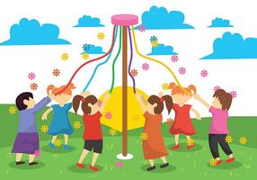The children have now learnt their country dance routine and will now move on to the maypole dance this half term. We are very excited about sharing these two dances with you at the Summer Revels, which will be held on **Saturday 21st June**. The PTA has been working extremely hard in organising this event, which is definitely one of the highlights in the school’s calendar. **If your child is unable to attend, please let the school know ASAP, so that routines can be adjusted accordingly.** Thank you.

**HEALTHY LUNCH BOXES**

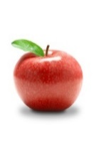As part of our aim to provide our children with healthy lifestyles, we would like to remind you that your child should be provided with a healthy packed lunch. If your child would like a snack at break time, please can you ensure it is a piece of fruit or vegetables, such as carrot sticks. **Please do not send your child to school with nuts, peanut butter or products containing nuts** as we do have children in school who are severely allergic to such items.

**WATER BOTTLES**

During the summer months, it is strongly recommended that all children have access to a water bottle, and have a sunhat for break/lunchtimes. Sun-cream should be applied before they come into school. It is important that your child is kept hydrated throughout the day, so should have a **named** plastic bottle of drinking water to have in class; **these should NOT be used for squash or fruit juice please.**

**SCHOOL CLUBS**

We will be offering a range of clubs during the Summer term. These will be detailed in the weekly newsletter.

**AND FINALLY…**

If you need to speak to me about your child at any point during the term, please contact the office or speak to me directly after school. If there are any parents who would like to listen to children read, please let me know.

With kind regards

Mrs Corrine Wellby